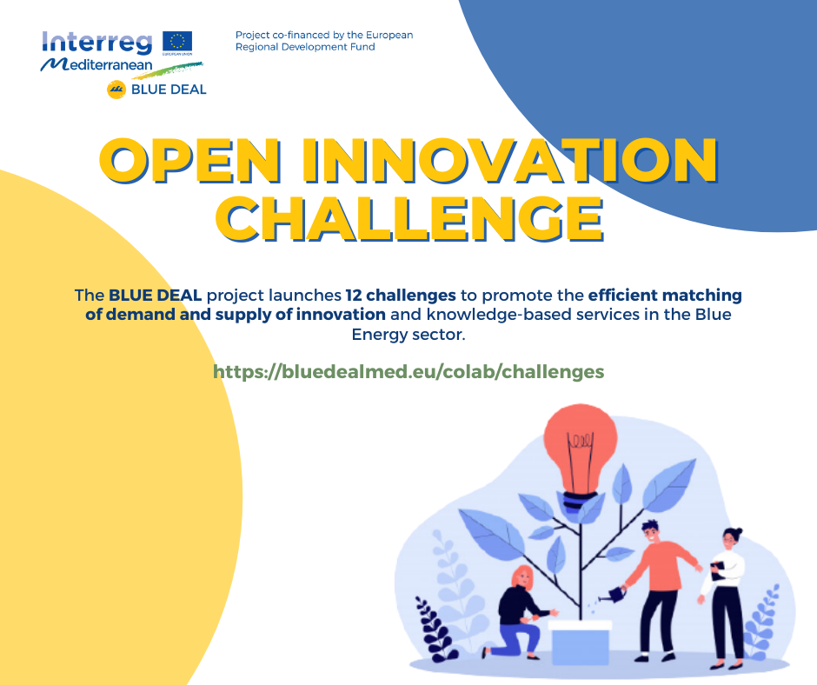

BLUE DEAL project launched an Open Innovation action that we think may interest you.

They are looking for the most established companies or entities, to interact with the entrepreneurial ecosystem and the researchers, by proposing challenges and problems to be solved.

We think that your organization could help to get solutions to the challenges and promote collaboration between entities that work with Blue Energy.

They are looking for solutions for 12 challenges in the following fields:
- Ports and Marinas looking for blue energy technologies to be installed and tested in their areas
- Islands looking for sea energies to get clean power and ensure their energy security.
- Companies looking for specific improvements to their developed technologies
- Public authorities, worried about training and jobs in this blue economy sector
- Municipalities looking for a defined local governance model to the decarbonization based on the BE production.

You can find all the information here: https://bluedealmed.eu/colab/challenges

