Press Release
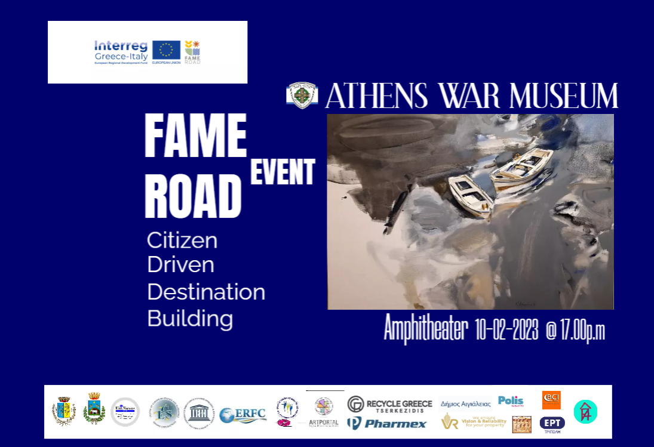

According to the art exhibition: "Art, Synod Heaven and Earth", a collaboration, sympraxis between the distinguished Curator Marina Gonda and the internationally renowned visual artist, Curator Miguel Gomez, will take place expo hall of the WAR Museum in Athens
In the Amphitheater at the War Museum, European Region Framework Cooperation, www.erfc.gr presents the Interregional project FAME ROAD www.fameroad.eu supported by the program INTERREG GREECE ITALY https://greece-italy.eu/
The main purpose of the project is to inspire & activate citizens from different regions of the planet to project ideas and take action, so that their region becomes an important destination.
Artists acquire their own voice and now become satellites of culture comunication through their works. The Artisan living labs interactive workshops are mainly aimed at the multi-level exchange of knowledge, experiences and artistic mentality, highly intertwined with human resources and multi-inspiration & resourcing. Civil society proposes and artists implement.
FAME ROAD has ensured the neutral platform where branded, targeted & public dialogue will be networked and translated into action. Participating regions are invited to become part of the society network, as well as the local governments. We invite those who want to work for a strengthened, organized Civil Society to participate and express ideas and initiatives at this event.

Citizen Driven Destination Building

F.A.M.E. ROAD
www.fameroad.eu
Food – Art – Movement -Energy – The Road to Country Experience
Amphitheater at the War Museum/Athens
10/2/23 17:00 ΜΜ

FAME ROAD:
Citizen Driven Destination Building

Chair: Maria Zilemenou: University Professor, President of the Center for European Studies : Ioannis Kapodistrias/ President of the Greek National Council of Associations and Centers for UNESCO
Mika Pappa Sevou: Management Consultant of the HELLENIC DANCE ARCHIVE Foundation/Secretary of IOV HELLAS in operational relations with UNESCO
Christos Tenzerakis: President of the GREEK DANCE ARCHIVE /f Secretary IOV-UNESCO N. Europe

PROGRAM
EXPERIENCE FAME ROAD
17:00 – 17:10 | Moderation | Lena Kyropoulos, Journalist-  Association European Journalists/ BCI MEDIA
17:10 –17:20 | Program FAME ROAD - Citizen Driven Destination Building | Nikos Petropoulos,  President ERFC -  Administrator FAME ROAD
17:20 - 17:40 | The War Museum of Athens as basic cultural structure in Greece | Anastasios Liaskos,  President/War Museum
17:40 – 18:00 | Culture Ideas FAME: from idea to action | Dr.Marina Gonta,  - History of Art  Sorbonne
18.00 - 18.10 | Art & Artists, wondrous Synod of Heaven & Earth | Paris Katsivelos, Actor-Director-Professor of Higher Schools of Dramatic Art Master's Professor Qualitative Journalism and New Technologies, European Institute of Communication, Austrian University D.U.K. and E.M.P.
18:10 - 18.20 | Destination Greece: «Art & Culture» | Evi Photopoulos  Visual artist, author
18:20 - 18.30 | The diachronically cultural relationship between Greece and Southern Italy | Christos Tenzerakis,  President of the GREEK DANCE ARCHIVE - ex-Secretary IOV-UNESCO N. of Europe
18:30 - 18:40 | Aegialia as a tourist destination through the FAME ROAD | Chrysoula Christia,  FAME ROAD Expert  - Aegialia
18:40 – 18:50 | Gravina in Puglia as a tourist destination through FAME ROAD | Antonio Prota,  FAME ROAD Expert  - Gravina in Puglia
18:50 – 19:00 | University of Puglia – UNIVERSUS Upgrading destinations through science | Federica Marangio,  Expert - Universus CSEI
19:00 – 19:10 | Grottaglie as a tourist destination through FAME ROAD | Giovanni Annicchiarico  FAME ROAD - Grottaglie
19:10 – 19-20 | The Greek tourism policy and the role of the active citizen | Giola Dionysopoulou, General Director of Tourism Policy
19:20 – 19:30 | The European policies for tourism and the role of the active citizen | Elena Kountoura, Member of the European Parliament
19:30 – 19:40 | The tourism infrastructure in Greece and the functioning of the active citizen | Christina Tetradis, Vice-President of the Hotel Chamber of Greece
19:40 – 20:00 | Intercultural tourism - new forms of thematic tourism | Notis Martakis Scientific partner of KEDE in tourism matters
20-00 – 20:10 | Circular economy & Tourism | Nikos Tserkezidis, President and CEO of RECYCLE GREECE
20:10 -20:20 | Cultural Sports Diplomacy: Aesthetic Team Gymnastics | George Vaiopoulos, President of Aesthetic Gymnastics of Greece
20:20-20:30 | Local Government & active citizens through FAME – You do not need to be FAMEous to enjoy a FAME territory. Rafina - Pikermi | Andreas Vassilopoulos, Candidate Mayor of Rafina - Pikermiou, President of AVMap Group, European Union Ambassador for the Environment/
20:30-20:40 | Business Development on the basis of FAME Citizen Driven Destination Building ideas | Fotis Kottis,  President of the Association of Chambers Ionian Islands

